1.15

In Haikou.

When switching computers need to fix:

1. Ytd and y2 0 problems

Reflection on tencent:

Back in 2013, a structurer (Snowy Tan) at Socgen was telling me that Tencent was a crowded trade.

Back in 2014/5/15, tencent was having a share split, Tencent was trading at 100 a share. Now it is trading at 440.

If a stock is making new highs, you never know what is the ceiling price.

In the same vein, if a stock is making new lows, you don’t know what is the floor price.

If a stock is making new highs, feel free to trade around the position. If it stagnates, don’t do much. If it retreats, cut a bit of position.

Good quality stocks always break new highs in the long due to earnings going up and a stable PE ratio. Earnings will go up due to inflation.

Escape low performing weeks(negative trade) / /years (by sharpe).

Cutting:

On negative month.

2018.1.16

Fut in discount. First time see a discount since end of Dec.

Need property exposure. Insurance and banks.

1.19

Revaluation of stocks.

Banks rally like insane.

Banks are cheap in china and the catalysts are

1. Valuation of the banks are low
2. In order for index to go up, banks have to perform

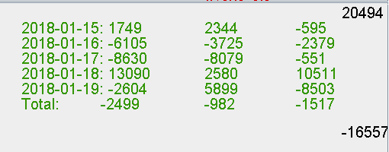

Week net: moutai : -9k

Changjiang : -3k

Meidi: -3k

ETF: +1k

Futures: +13k

Futures pm dipping strategy went well on wed/thurs.

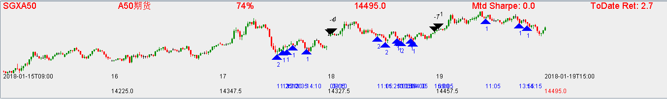

Wed: pm buy, selling on thurs confusion period. (Good)

Thurs: late am- pm buy, selling on thurs close, fri confusion period. (Good)

Fri: AM buy (not on the lows) was not good. The PM buys didn’t work and don’t add position when pmcoy doesn’t support. Was only good that no position was added on a losing trade.

1. Focus on pm strategies, AM let existing delta play out, low sharpe on AM strategies not good.
2. Delta cap. Accumulate up to 1/3 position and disseminate. If drops to the lows at close, pick up at flat PD for next open.
3. Wtd strong sharpe stocks are more likely to rebound than weak wtd stocks.